NAME: Sharvayu Zade
PRN: 23070521135
SEC: B(B2)

Practical 6 part 2: Regular Expressions in JavaScript
Introduction
Regular Expressions (regex) are patterns used to search, match, and manipulate text. They are extremely powerful for validating input, extracting data, and performing complex string operations.
Example in real life:
● Checking if an email address is valid.
● Finding all phone numbers in a document.
● Replacing multiple spaces with a single space.
Basic Regex Syntax
Symbol | Meaning | Example
^ | Start of string | /^Hello/ matches "Hello world"
$ | End of string | /world$/ matches "Hello world"
. | Any character except newline | /h.t/ matches "hat", "hit"
* | 0 or more occurrences | /go*d/ matches "gd", "god", "good"
+ | 1 or more occurrences | /go+d/ matches "god", "good" but not "gd"
? | 0 or 1 occurrence | /colou?r/ matches "color" or "colour"
[abc]  [^abc]  {n} | Match a, b, or c  Match anything except a, b, or c  Exactly n times | /gr[ae]y/ matches "gray" or "grey"  /[^0-9]/ matches non-digits  /\d{3}/ matches three digits

{n,} At least n times /\d{2,}/ matches two or more digits
{n,m} | Between n and m times | /\d{2,4}/ matches 2, 3, or 4 digits
\d | Digit (0-9) | /\d/ matches 1
\w | Word character (letters, digits, underscore) | /\w/ matches A, 1
\s | Whitespace (space, tab, newline) | /\s/ matches space
` | ` | OR operator

JavaScript Regex Functions
Method | Description
test() | Returns true or false if regex matches.
exec() | Returns the first match as an array or null.
match() | Returns an array of all matches.
matchAll() | Returns an iterator with all matches + groups.
replace() | Replaces matched text with something else.
search() | Returns index of first match or -1.
split() | Splits string using a regex pattern.
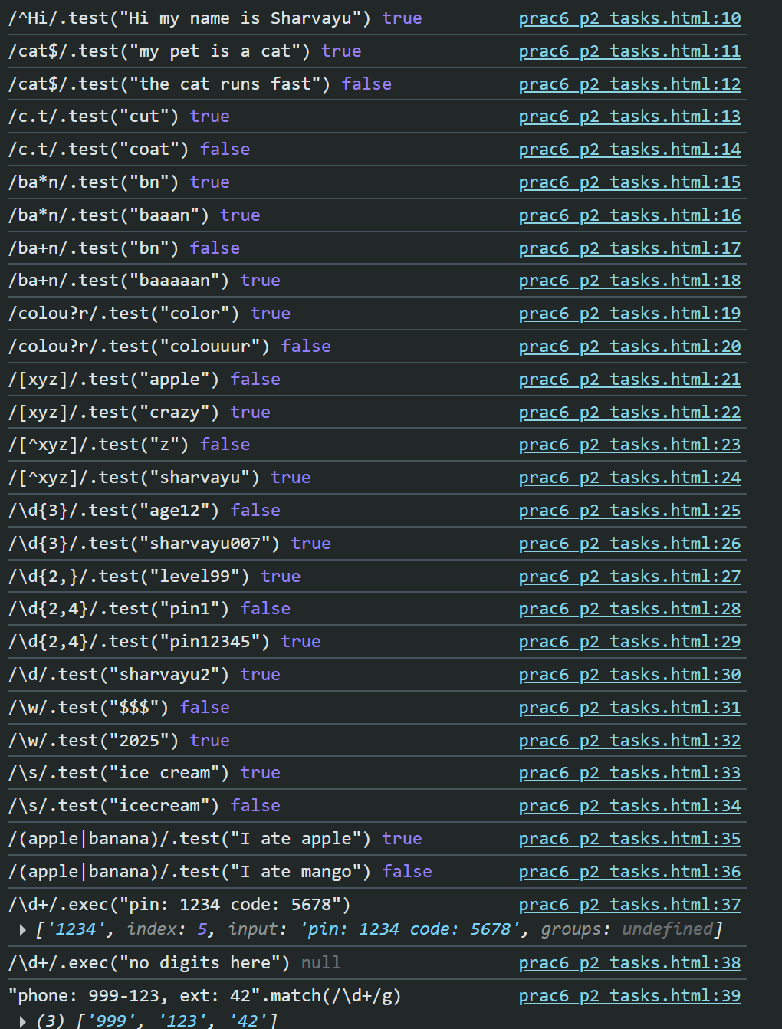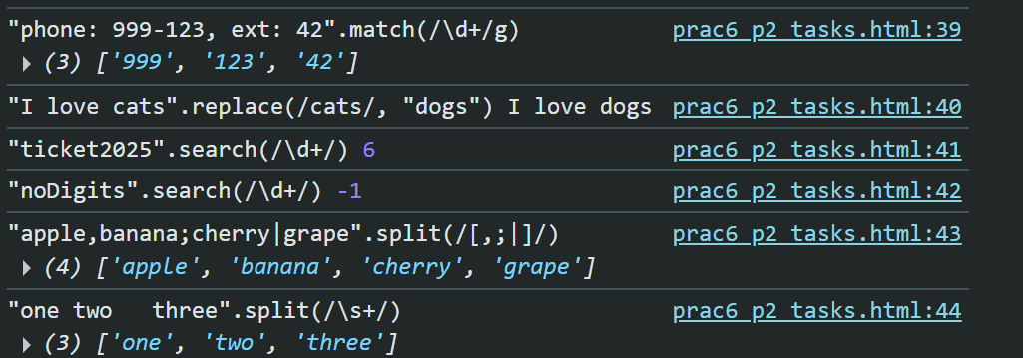
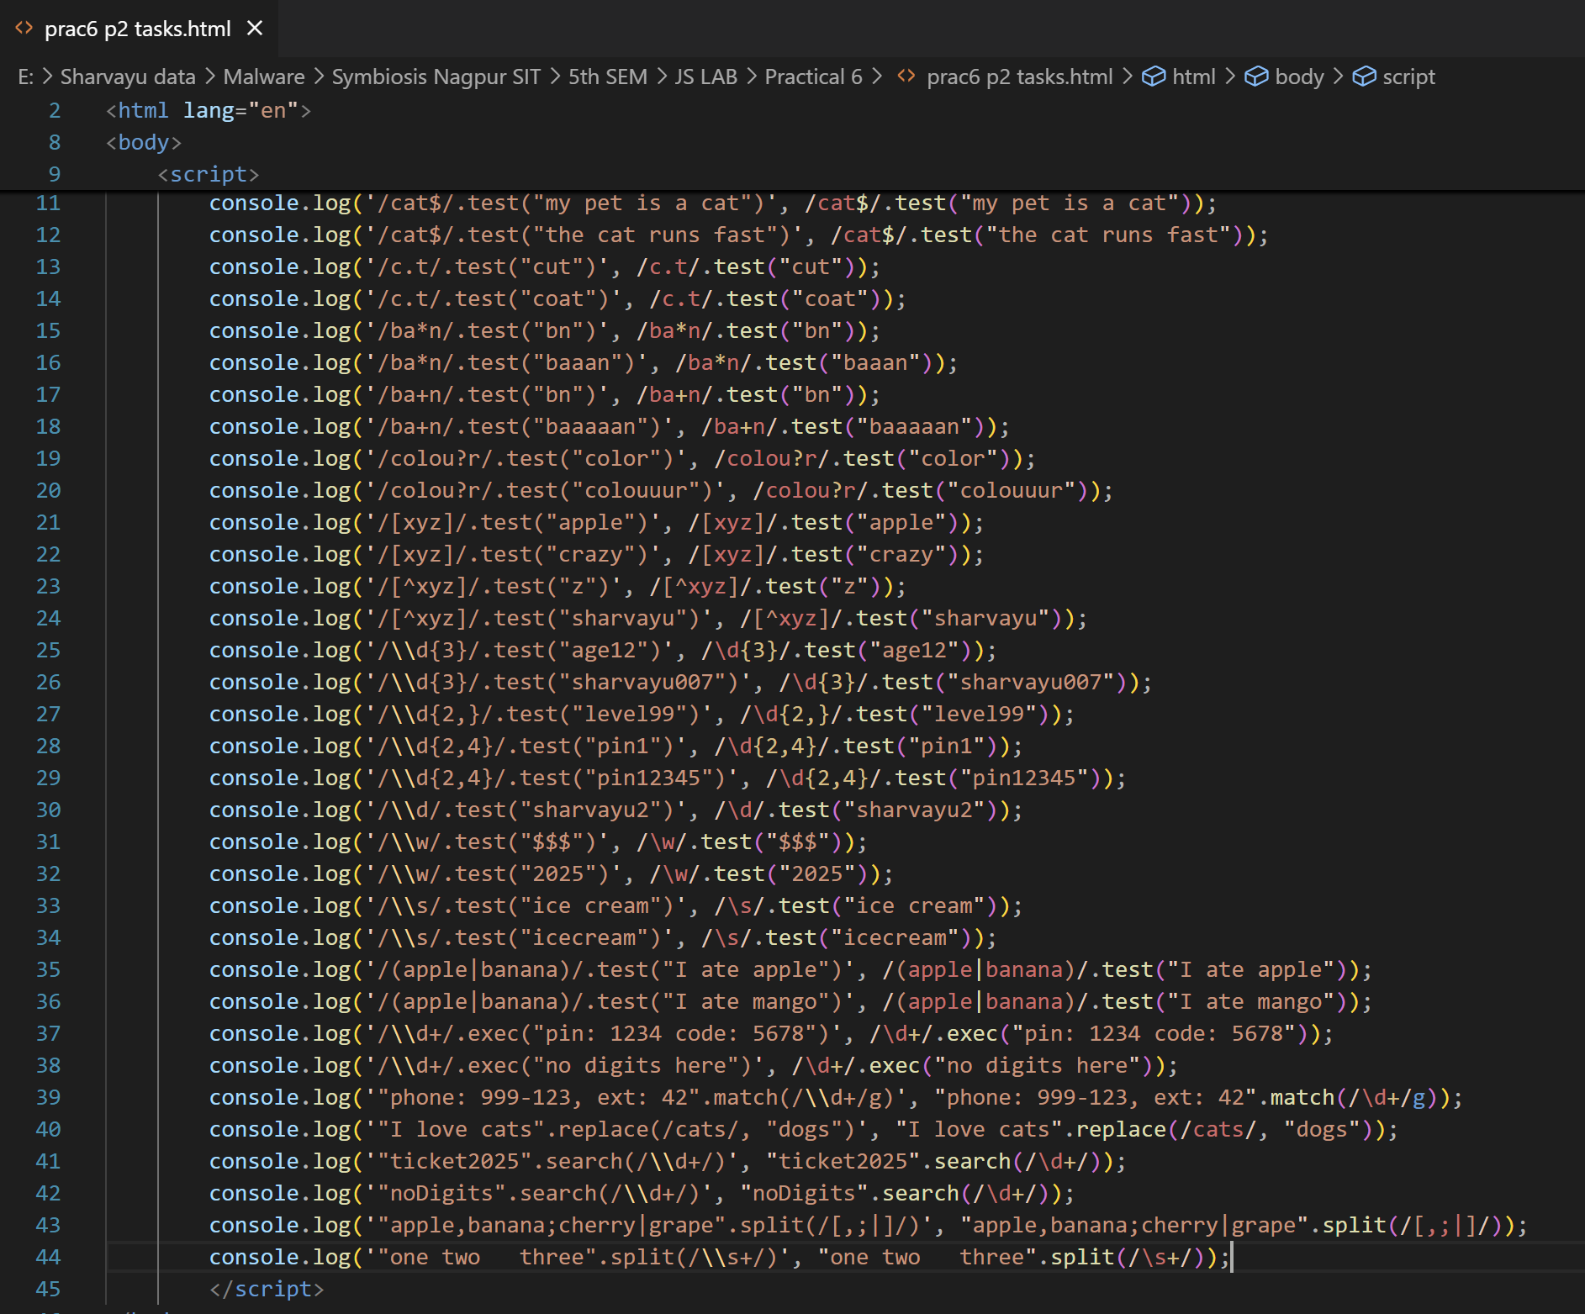
Examples
Example 1: Test if a string contains digits
let regex = /\d/;
console.log(regex.test("Hello123")); // true
console.log(regex.test("Hello")); // false 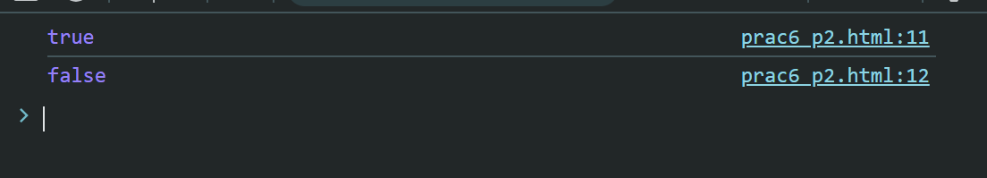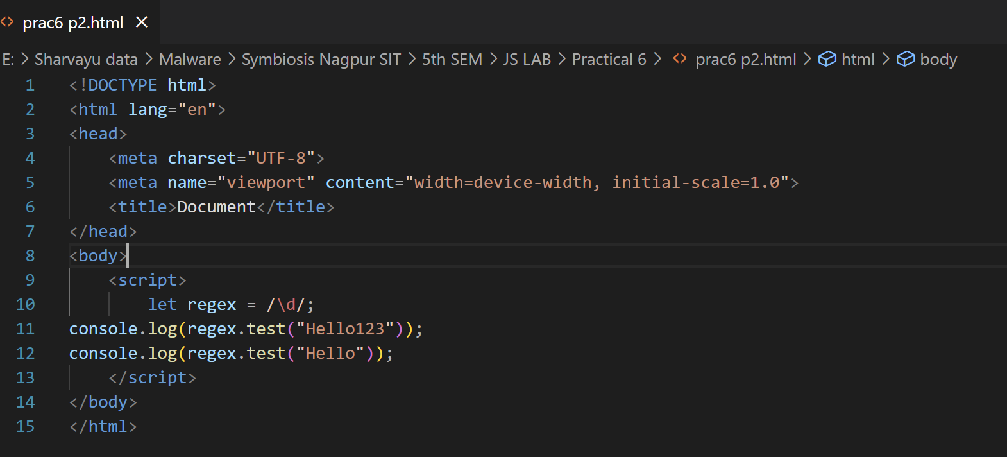
Example 2: Validate Email Address
let emailRegex = /^[A-Za-z0-9._%+-]+@[A-Za-z0-9.-]+\.[A-Za-z]{2,}$/;
console.log(emailRegex.test("student@example.com")); // true
console.log(emailRegex.test("student@.com")); // false
Explanation:
● ^ → Start of string
● @ → Must contain @
● . → Dot before domain
● $ → End of string 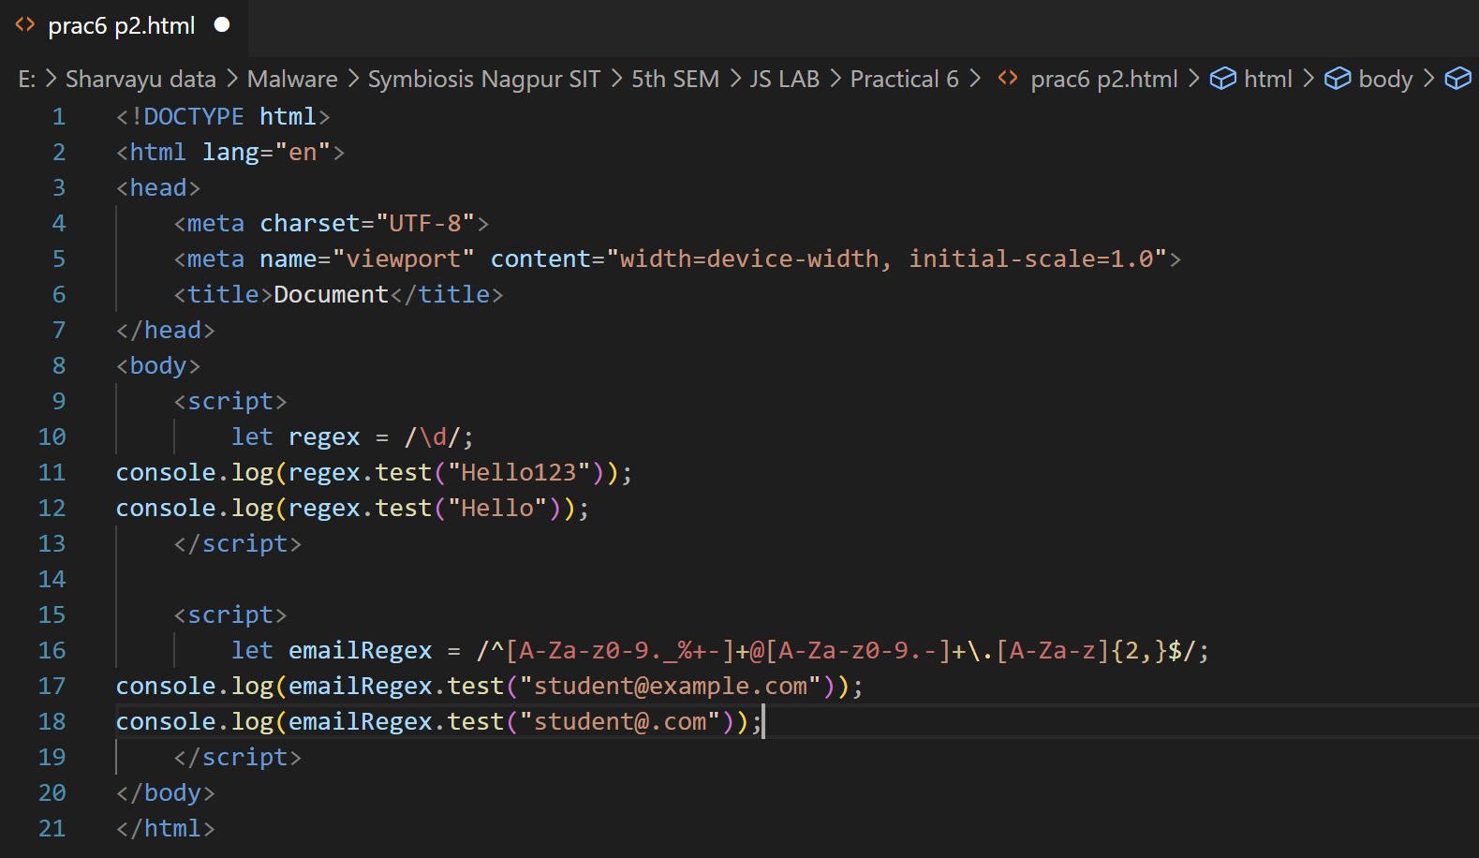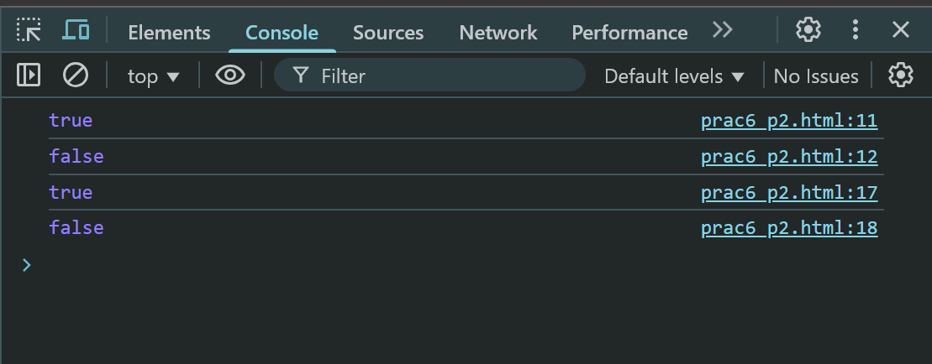
Example 3: Find all words in a string
let text = "JavaScript is fun!";
let words = text.match(/\w+/g);
console.log(words); // ["JavaScript", "is", "fun"] 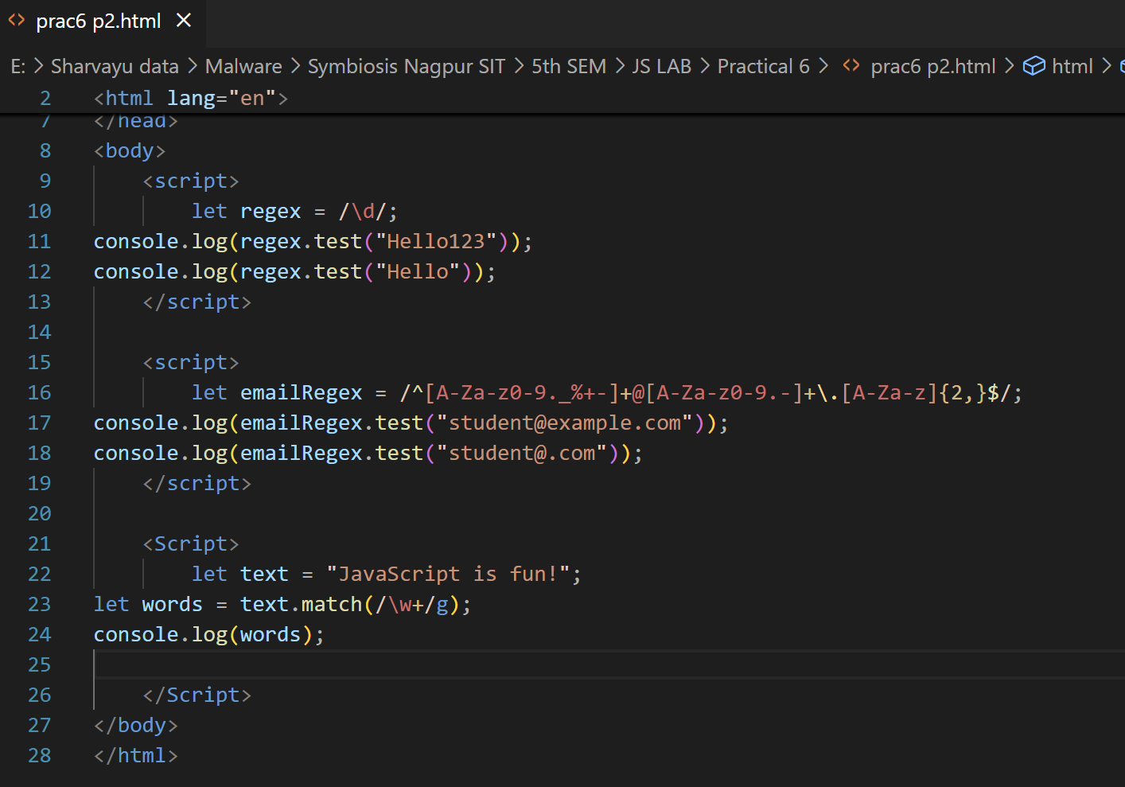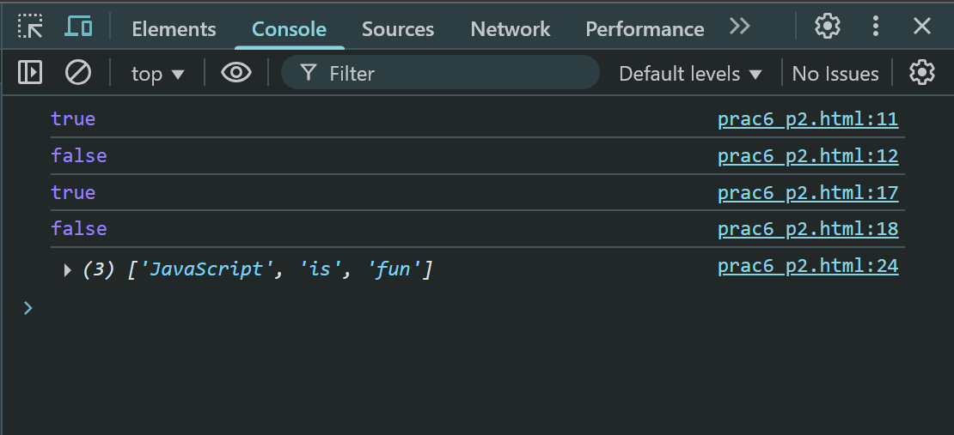
Example 4: Replace multiple spaces with single space
let messy = "Hello World from JavaScript";
let clean = messy.replace(/\s+/g, " "); 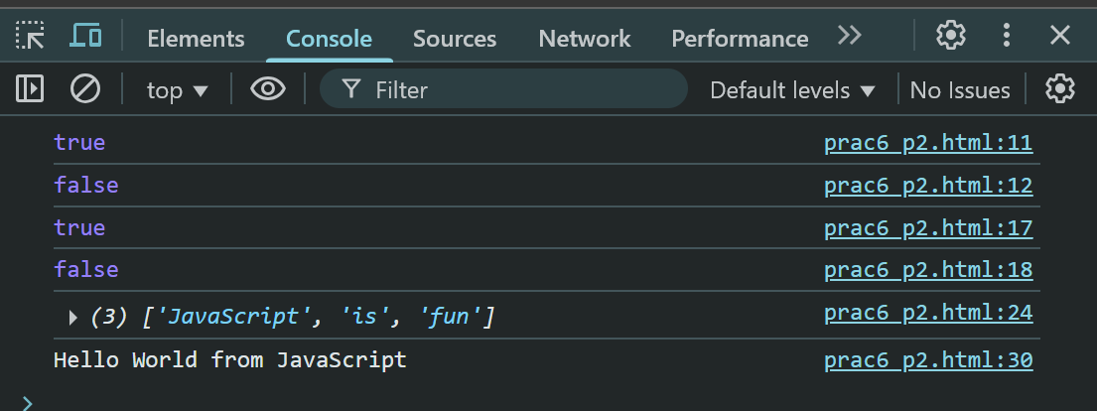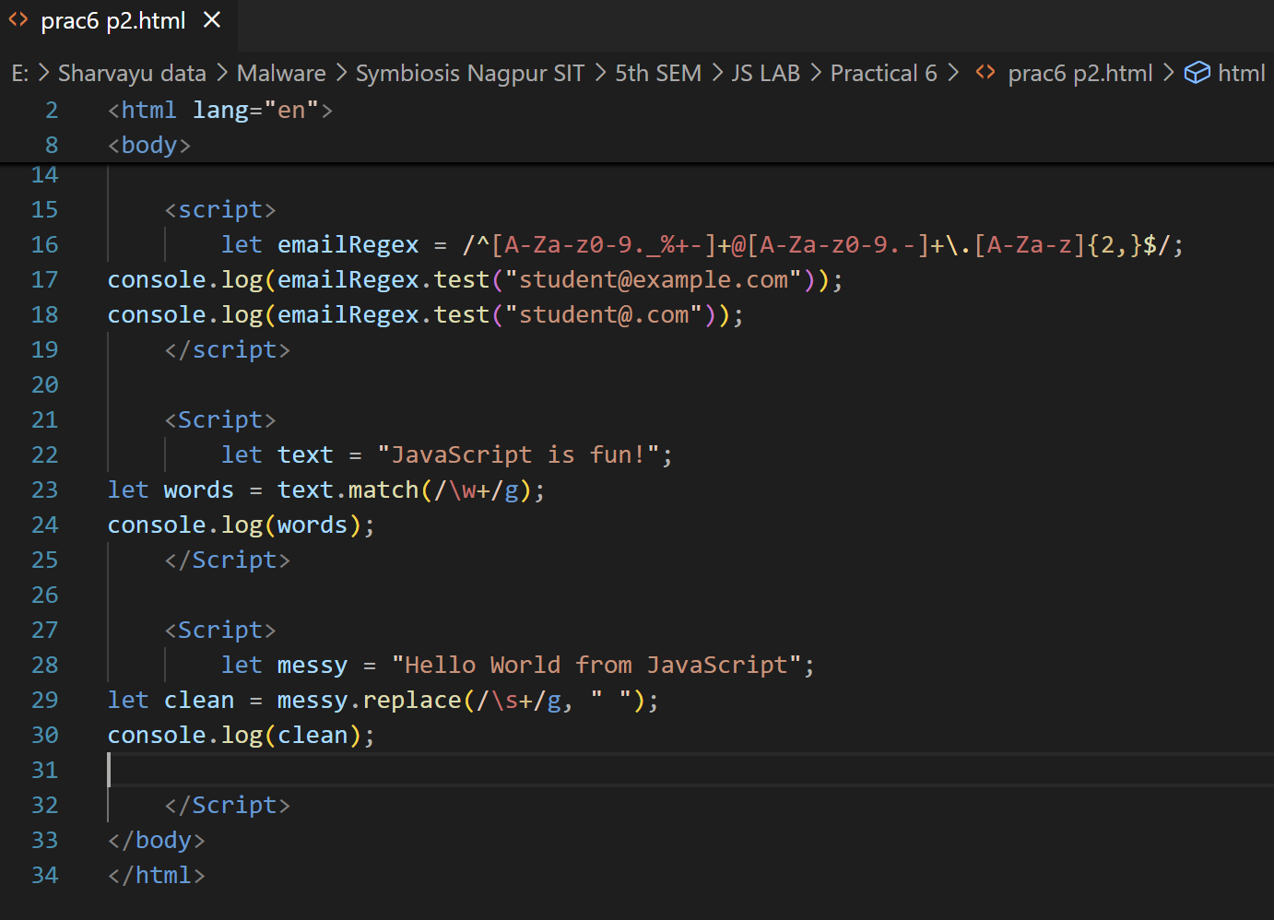
console.log(clean); // "Hello World from JavaScript"
Lab Tasks
Task 1: Validate Mobile Number
Create a regex to check if a number:
Starts with 6, 7, 8, or 9
Contains exactly 10 digits
Example Valid: 9876543210
Example Invalid: 1234567890
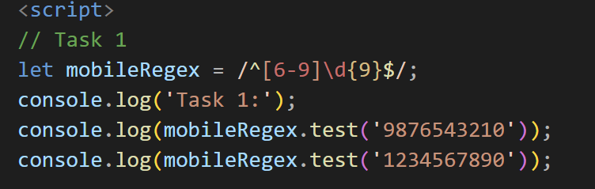
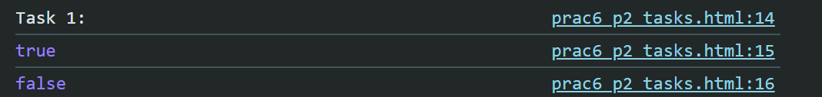Hint:
let mobileRegex = /^[6-9]\d{9}$/;
Task 2: Extract Dates from Text
● Input: "Today's date is 12/09/2025 and tomorrow will be 13/09/2025."
● Output: ["12/09/2025", "13/09/2025"]
Hint:
let dateRegex = /\d{2}\/\d{2}\/\d{4}/g; 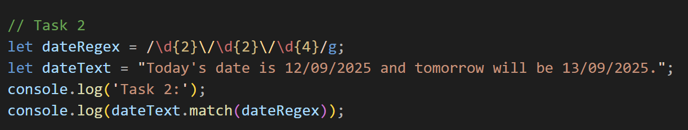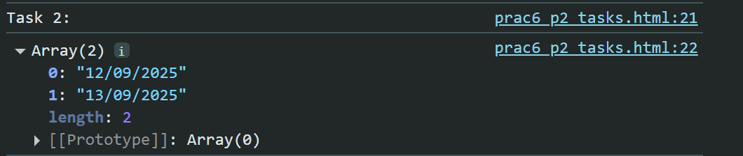
Task 3: Password Strength Checker
Rules:
● Minimum 8 characters
● At least 1 uppercase, 1 lowercase, 1 number, and 1 special character
Regex:
let passwordRegex = /^(?=.*[a-z])(?=.*[A-Z])(?=.*\d)(?=.*[@$!%*?&])[A-Za-z\d@$!%*?&]{8,}$/;
Examples:
● "StrongPass1!" → Valid
● "weakpass" → Invalid 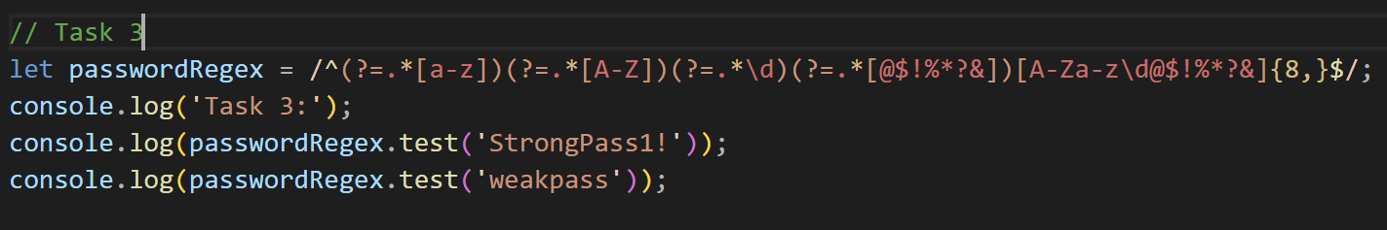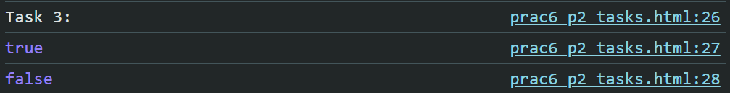
Task 4: Find Duplicate Words
● Input: "This is is a test test"
● Output: ["is", "test"]
Hint:
let text = "This is is a test test";
let dupRegex = /\b(\w+)\s+\1\b/g;
console.log(text.match(dupRegex)); // ["is", "test"] 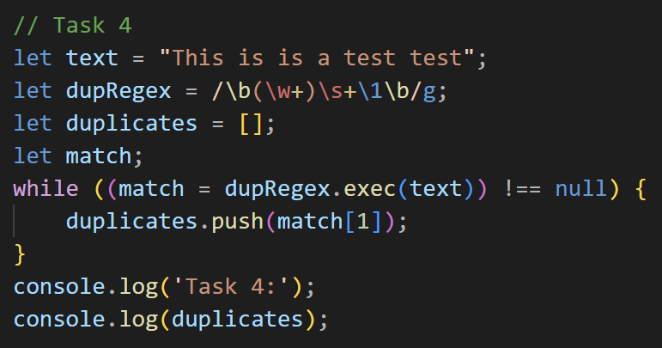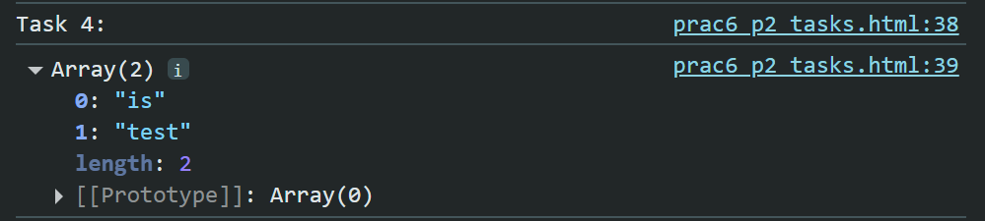
Task 5: Extract Hashtags from a Tweet
● Input: "Learning #JavaScript is #fun and #exciting!"
● Output: ["#JavaScript", "#fun", "#exciting"]
Hint:
let tweet = "Learning #JavaScript is #fun and #exciting!";
let hashtags = tweet.match(/#[A-Za-z0-9_]+/g);
console.log(hashtags); 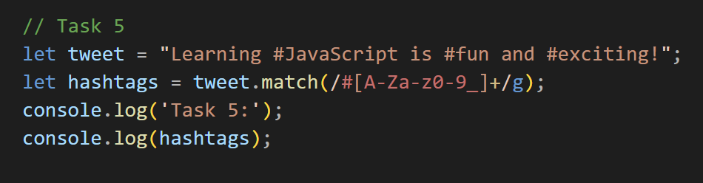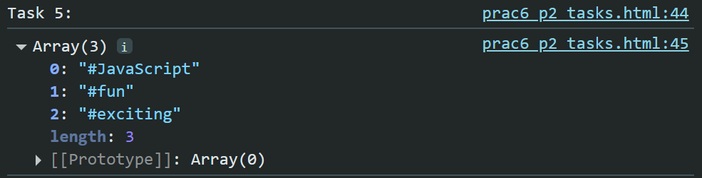
Practice Problems
Problem | Expected Input | Expected Output
Validate PIN | "440001" | Valid
Validate URL | "https://google.com" | Valid
Extract Numbers | "Order 123 costs $45" | ["123", "45"]
Extract Emails | "Contact us at help@abc.com or sales@xyz.org" | ["help@abc.com",  "sales@xyz.org"]
